Disincentive Density PWL HMA Pavement, Item 804.2010 – Example DT1310 (NER20-0130)
- Bid Item Name:
Disincentive Density PWL HMA Pavement, Item 804.2010
- Quantity Involved:
Enter dollar amount of disincentive (include the negative sign)
- Units:
DOL
- Test Results:
See Disposition Explanation
- Spec Requirements: (update the STSP date appropriately. 460-040: Test Strip / 460-050: PWL QMP)
STSP 460-040 (20191121)
STSP 460-050 (20191121)
Density PWL value >= 90

- Disposition Explanation: (only include the spreadsheet references that have disincentives)
TEST STRIP:
HMA Density PWL value is calculated in Density Pay Factors worksheet of the HMA PWL Test Strip spreadsheet. Disincentive for 4 LT 58-28S Test Strip is $205.77
Disincentive for 3 LT 58-28S Test Strip is $89.50

PRODUCTION:
HMA Density PWL values are calculated in Density Pay Factors worksheet of the HMA PWL Production spreadsheet.
Disincentive for 4 LT 58-28S Mainline Production is $155.52
Disincentive for 3 LT 58-28S Mainline Production is $289.65

Data was reviewed by project staff and Region Materials section.

Disincentives are applied in CCO #2.
- Placement Date:
Leave Blank
- Sample Date:
Leave Blank
- Sample Location:
Leave Blank
- Usage:
Select One:
HMA Mainline Upper (4 LT 58-28S) & Lower (3 LT 58-28S) Layers
HMA Mainline Upper Layer (4 LT 58-28S)
HMA Mainline Lower Layer (3 LT 58-28S)
- Usage Location:
Select One:
See HMA PWL Test Strip Spreadsheet
See HMA PWL Production Spreadsheet
See HMA PWL Test Strip & Production Spreadsheet

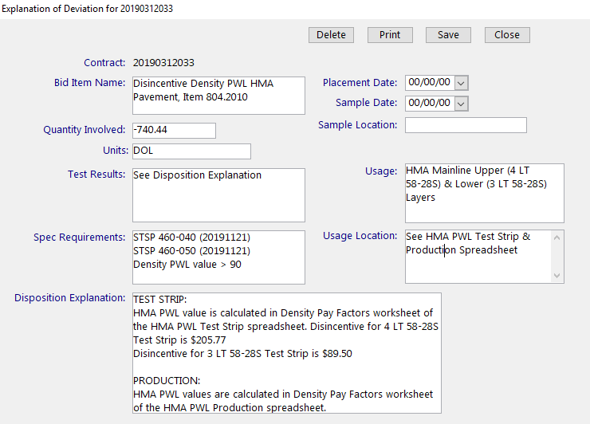
Figure: MIT Entry Disincentive Density PWL HMA Pavement Example

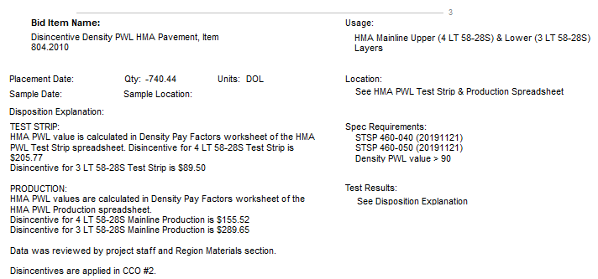
Figure: Printed DT1310 Disincentive Density PWL HMA Pavement Example

